Week 1 - Assessment

**Q1. What is Deep Learning?**

Deep learning is a type of **machine learning** that teaches computers to perform tasks by learning from examples, much like humans do. Imagine teaching a computer to recognize cats: instead of telling it to look for whiskers, ears, and a tail, you show it thousands of pictures of cats. The computer finds the common patterns all by itself and learns how to identify a cat.

It can also be used to distinguish or classify different entities for example: classifying cat and dog, car and a motorcycle, etc. The model learns to distinguish between these entities by learning and understanding the patterns that make the entity what it is.

Deep learning is used in many real-world applications, including self-driving cars, voice assistants, medical diagnosis, and even generating realistic images. One of its biggest advantages is that it can handle massive amounts of data and learn directly from raw inputs, often **without human intervention**. However, deep learning requires large amounts of computing power and data to be effective. Despite these challenges, it has revolutionized fields like natural language processing and computer vision, making tasks like automatic translation, facial recognition, and speech understanding far more advanced than ever before.

**Q2. What is Neural Network and its types?**

Neural networks are a type of machine learning model inspired by the human brain. They consist of layers of interconnected nodes, called neurons, that process information. The input layer receives data, the hidden layers analyse and extract features, and the output layer generates the final decision or prediction. As data passes through these layers, the network learns complex patterns, making it effective for tasks like image recognition, natural language processing, and autonomous systems.

**Types of Neural Networks**:

1. Feedforward Neural Network (FNN) – The simplest type, where information flows only in one direction (from input to output). Used for classification and regression tasks.

2. Convolutional Neural Network (CNN) – Designed for image and video recognition. It uses convolutional layers to detect patterns and features like edges and textures.

3. Recurrent Neural Network (RNN) – Handles sequential data, such as text and speech, by maintaining memory of previous inputs. Used in chatbots, translation, and speech recognition.

4. Long Short-Term Memory (LSTM) – A special type of RNN that can remember long-term dependencies in data, useful for predictive modeling and time-series forecasting.

5. Generative Adversarial Network (GAN) – Uses two networks (generator and discriminator) to create realistic synthetic data, such as AI-generated images.

6. Graph Neural Network (GNN) – Processes data that is structured as graphs (e.g., social networks or molecular structures) to learn relationships between nodes.

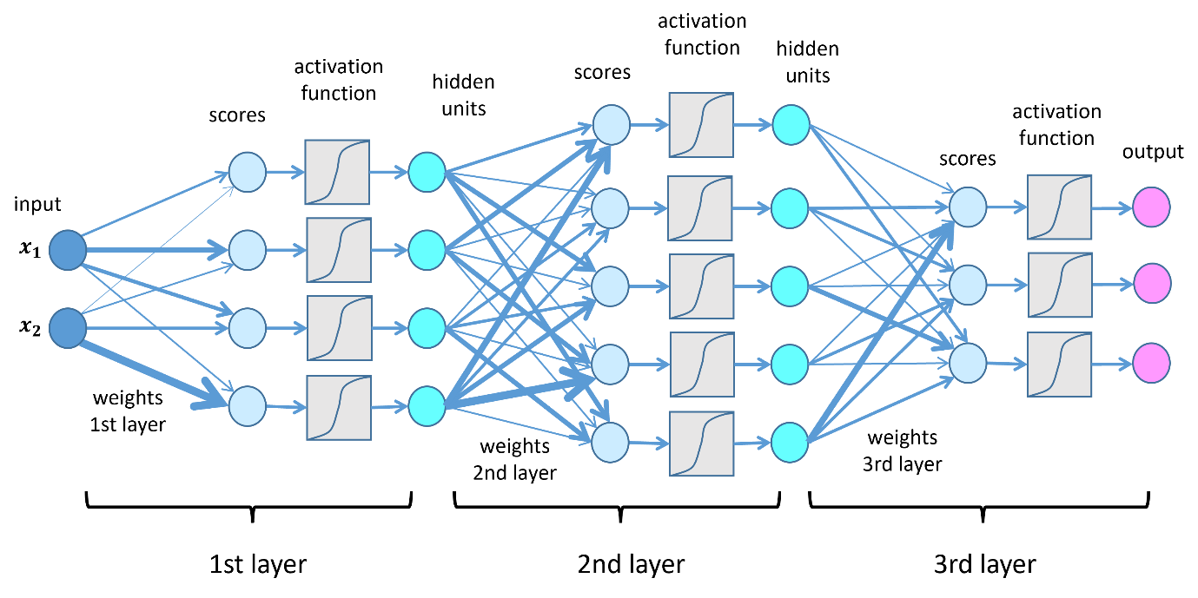

**Q3. What is CNN in simple words?**

A Convolutional Neural Network (CNN) is a type of deep learning model that is great at recognizing patterns in images and videos. Think of it like how your brain processes visuals—CNNs learn to detect edges, shapes, and textures in pictures to understand what’s in them. Instead of looking at an entire image all at once, a CNN examines small sections at a time, recognizing important features like eyes in a face or wheels in a car.

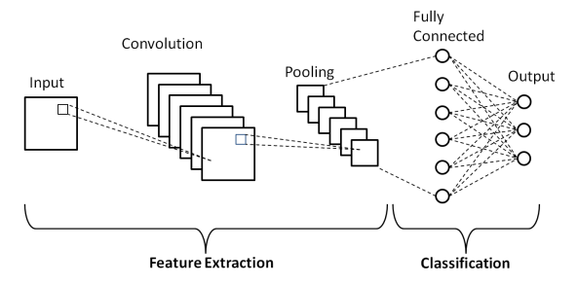

CNNs are widely used in things like face recognition, self-driving cars, and medical imaging. They’re powerful because they can automatically learn the most important details in images without needing a human to manually label every feature.

CNNs are widely used in real-world applications because they excel at recognizing patterns in images and videos. Here are some simple yet powerful applications:

1. Face Recognition – Your phone's facial unlock system relies on CNNs to identify and verify your face by analysing unique features like eyes and nose shape.

2. Medical Imaging – Doctors use CNNs to detect diseases from X-rays and MRIs, helping identify conditions like tumours or fractures.

3. Self-Driving Cars – CNNs help autonomous vehicles recognize road signs, pedestrians, and obstacles for safe driving.

4. Object Detection in Photos – When your phone suggests tagging friends in a photo, it's using CNNs to detect and classify faces.

5. Quality Inspection in Manufacturing – Factories use CNNs to inspect products for defects, ensuring high-quality production.

**Q4. Project Pipeline Notes.**

1. **Data Collection and Data Loading:** This initial phase focuses on acquiring the necessary image data for the project. Sources like Kaggle.com are common for finding datasets. The data then needs to be loaded into the working environment, and Google Colab is often used for this purpose, providing a cloud-based platform for data access and computation.
2. **Image Processing and Image Augmentation:** Once the data is loaded, it often requires preprocessing. This can involve resizing images to a consistent size. Image augmentation techniques are applied to artificially increase the dataset size and introduce variability (e.g., rotations, flips). This helps the model generalize better to unseen data.
3. **Build CNN - TensorFlow:** This step involves constructing the Convolutional Neural Network (CNN) architecture. TensorFlow, a popular open-source library, is the framework used to define and build the layers and connections of the CNN model.
4. **Test and Evaluate:** After the CNN model has been trained, its performance needs to be assessed. This is done using a separate test dataset that the model has never seen before. The goal is to evaluate how well the model generalizes and to measure its accuracy and other relevant metrics.

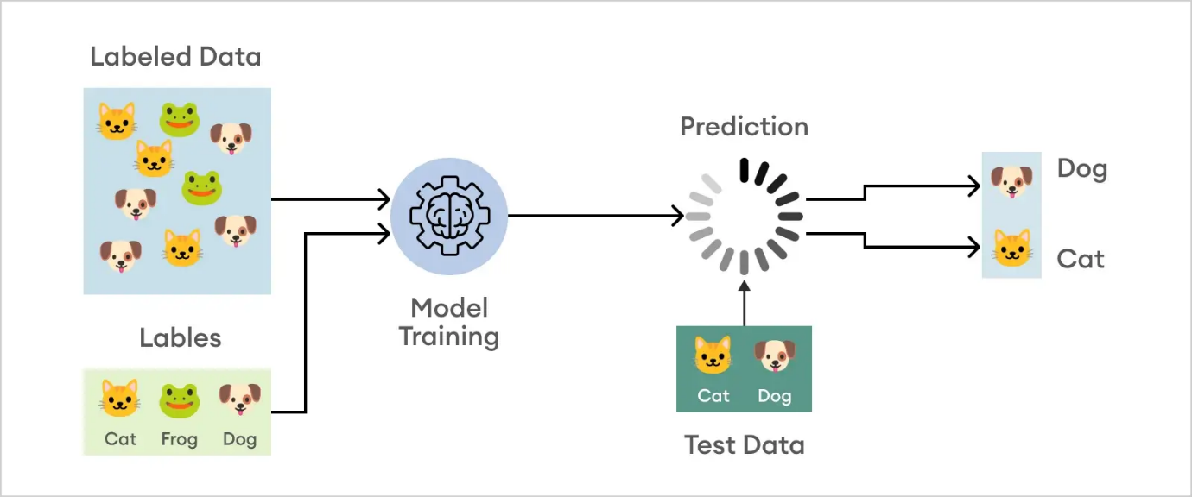

**Model Training and Evaluation Process:**

* Training images are fed into the CNN model.
* A validation dataset is used during training to monitor the model's performance on unseen data.
* After the training phase is complete, the trained model is evaluated using a test dataset to assess its performance.
* The model's output is indicated as "Binary," suggesting a binary classification task.